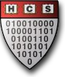
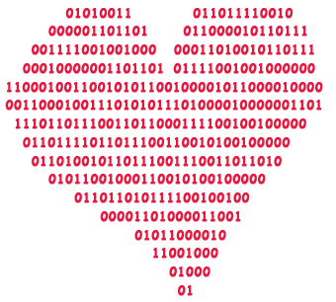
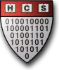
DATAMATCH

Date:
FEBRUARY 7-14TH

Surveys Emailed on the 7th!

*TAKE THE LOVE SURVEY*
(between 02/07 – 02/13)
*GET (data)MATCHED*
(with 10 other Harvard undergrads)
*GO ON A DATE*
(on HCS’s tab)

PRESENTED TO YOU BY THE: HARVARD COMPUER SOCIETY

Valentine’s Day

